School Supply List
Marvin Moss Elementary
Miss Foster’s Pre-K
2024-2025
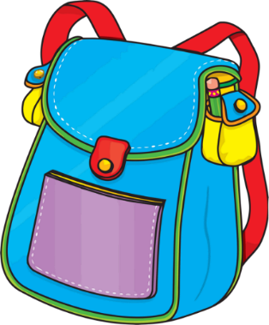

1—8 pack of large crayons
1 package of “my first” pencils (they are larger than regular pencils)
2 Rolls Paper Towels
1 Box of Kleenex
2 pkgs. Baby Wipes
1 package of white card stock
1 package of Mr. Clean Magic Erasers

Class Fee: $30.00 Please Make Checks payable to Marvin Moss Elementary.

Optional Items for Art and Sensory Centers:

Dot Markers, Foam Paint, Playdough, 9-inch Paper Plates, Seasonal Stickers, Pom Poms, Clear Contact Paper, Astro Bright Paper, liquid glue

Each afternoon our students will be having a snack. Please consider adding to our snack cabinet by providing snacks that can be passed out such as: goldfish, pretzels, fruit snacks, animal crackers, popcorn, cheese, crackers, juice boxes. Fresh Fruit is also a good option but please check with me first regarding allergies.

$30.00 Class Fee: used for special projects, foodie Friday, special materials for arts and crafts and centers.

